4-H Breeding Ewe ID Guide
- Youth should log into their 4Honline account (https://v2.4honline.com/#/user/sign-in)
- On the left select Animals
- Then Click “Add an Animal”

- Select “Add New Animal”

- Animal Type: Sheep Breeding
- Tag: Animal tag number or Scrapies Tag Number
- Save
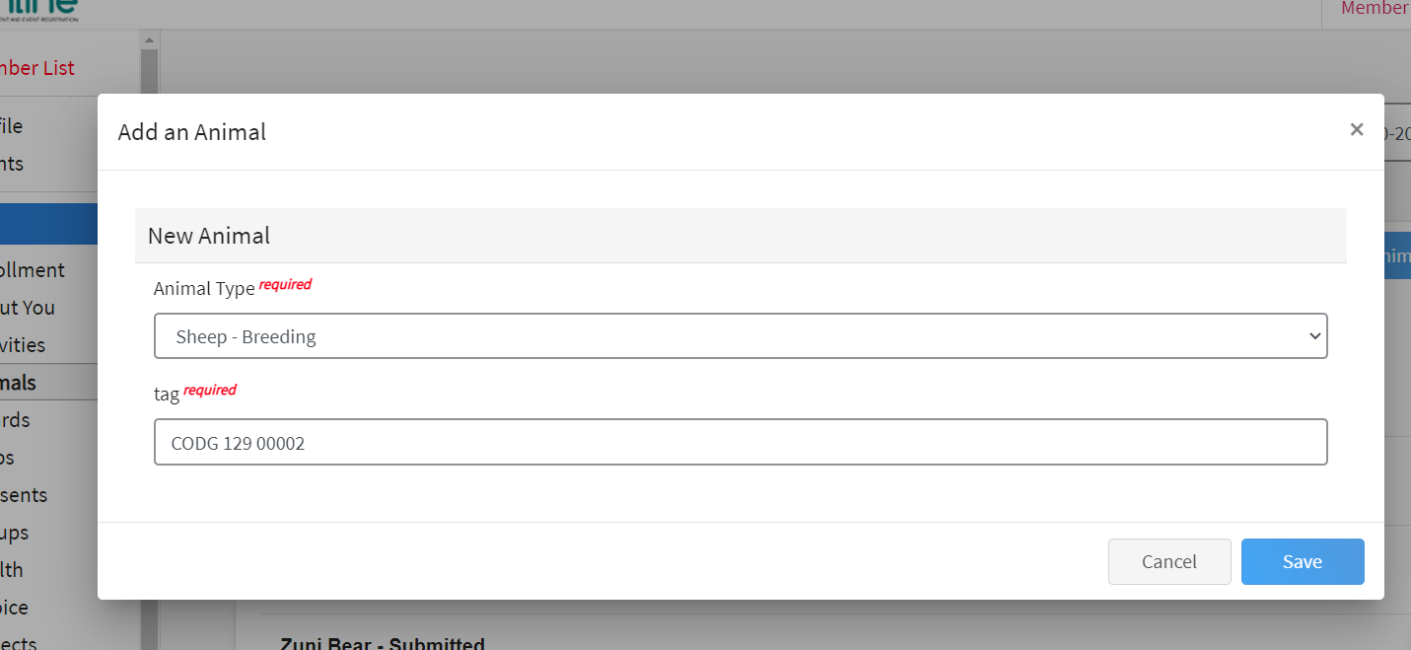

- Click “Show Questions”
- Fill out questions
  - Animal Name: Animal Name
  - Animal Birthday: Birthdate of animal OR Purchase Date
  - Birth Weight: Birth Weight OR weight at purchase date
  - Breed: Breed
  - Colors & Markings: Any distinguishing color or markings
  - Dam Name: if known
  - Dam Tag: if known
  - Dam tattoo: if known
  - NAIS Premises ID: Necessary for CSF, but not required in Douglas County
  - Scrapie Flock ID: Scrapies Tag Number
  - Animal Gender: Animal Gender
  - Tag: Animal tag number or Scrapies Tag Number
  - Tattoo: If animal has one
  - Next
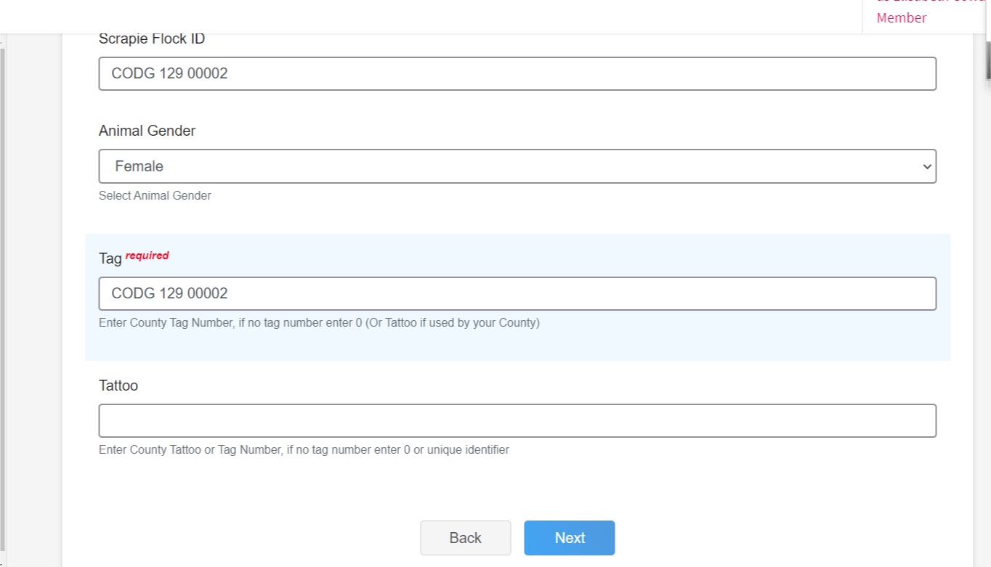

- Upload Files
  - Sheep - Breeding (Photo 1)- Front Picture
  - Sheep - Breeding (Photo 2) – Side Profile
  - Sheep - Breeding (Photo 3)– Scrapies Tag picture
  - Sheep - Breeding (Photo 4)– 4th picture of youth and animal if youth not in any of the first 3 pictures OR a picture of distinguishing marking on animal.
  - County Use Form (Sheep – Breeding) – Upload Douglas County Breeding Ewe Form
  - Sheep - Breeding (Registration Papers)- If you have them
  - Sheep - Breeding (Bill of Sale) – If you have them
  - Sheep - Breeding (Lease Agreement) – Contact Mercedes
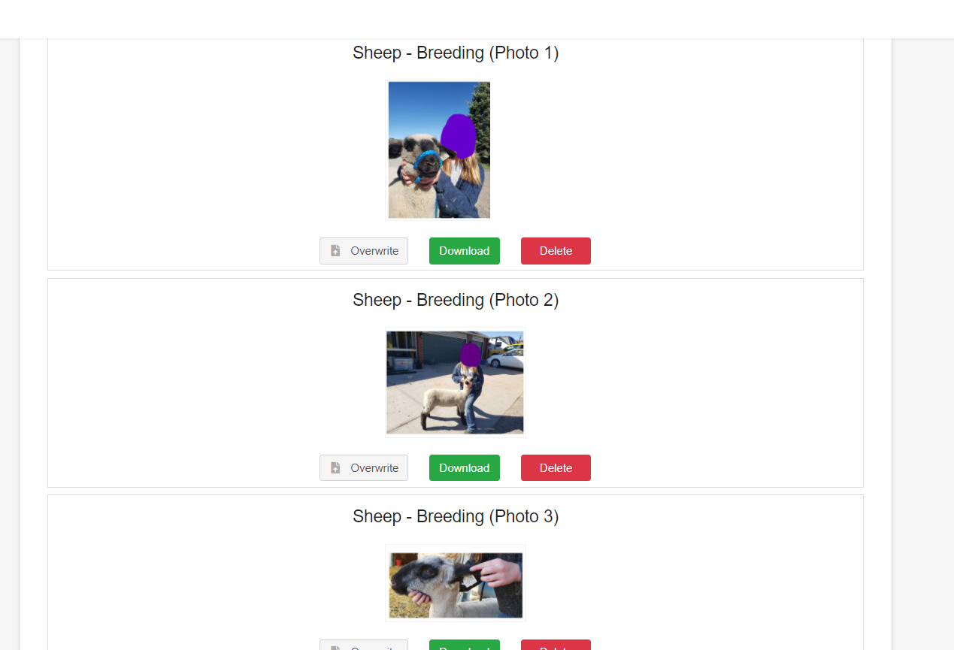

- Click next

- Review ID
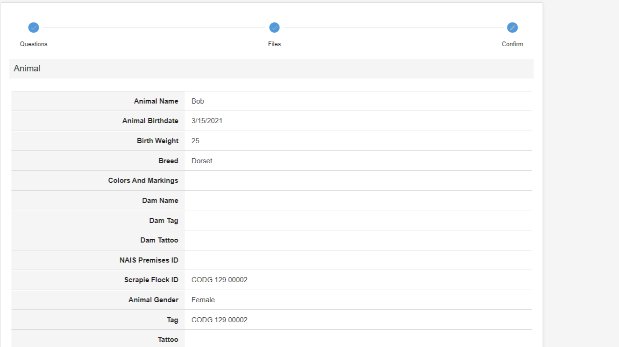
- Scroll Down & Hit Submit!
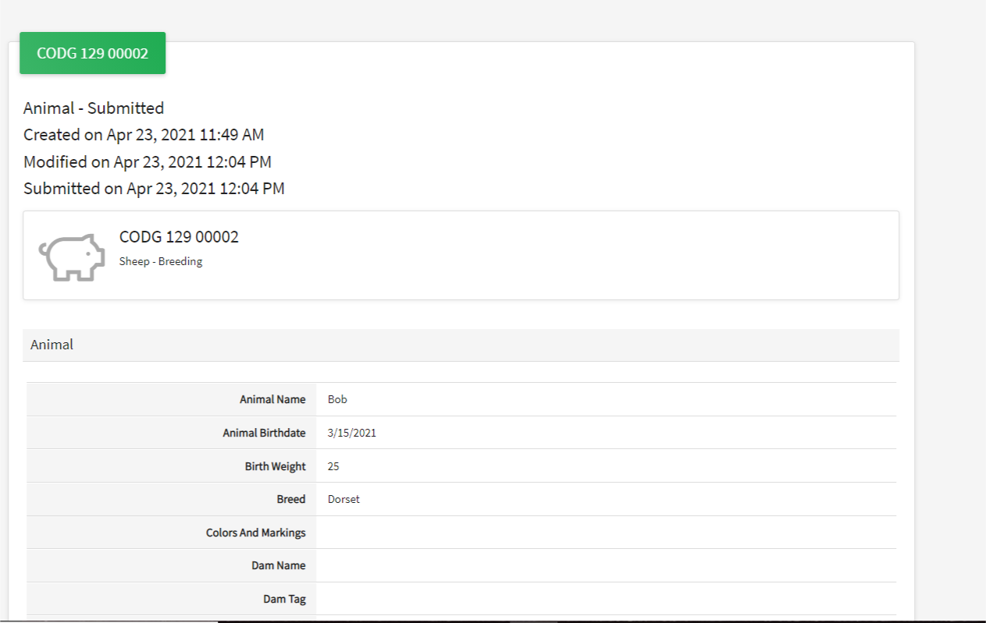
- See submitted ID

- Check! On the left side of your screen click on “Animals” again to bring you back to the Animal page for the youth. This will show you all animals ID’d for that youth! Here you see the 3 examples I have been working onL 2 dog’s (Zuni & Shadow Bear) and 1 horse (Ariat)

- Frequently Asked Questions
- 4Honline is not working for me- Keep trying and if it continues to not work please email the office ASAP. The county ID deadline is May 4th and we needs a completed 4Honline ID or an email with necessary information by that deadline.

Video Tutorial: https://youtu.be/01I_kRWTHfk

DO NOT WAIT UNTIL THE LAST MINUTE TO ID YOUR ANIMALS!

