4-H Llama/Alpaca ID Guide
- Youth should log into their 4Honline account (https://v2.4honline.com/#/user/sign-in)
- On the left select Animals
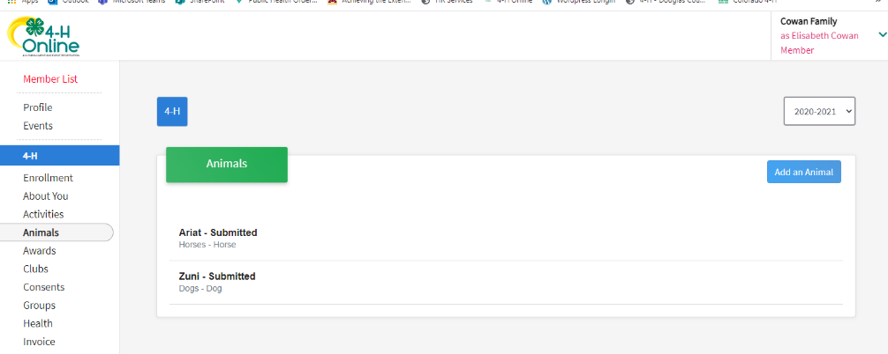
- Then Click “Add an Animal”

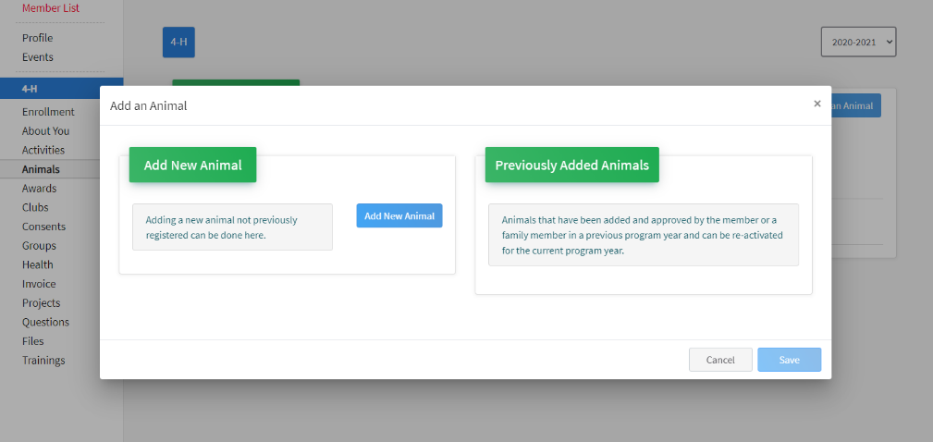
- Select “Add New Animal”

- Animal Type: Llama/Alpaca
- Tattoo: Tattoo number if the animal has one, otherwise put your favorite number or 1234
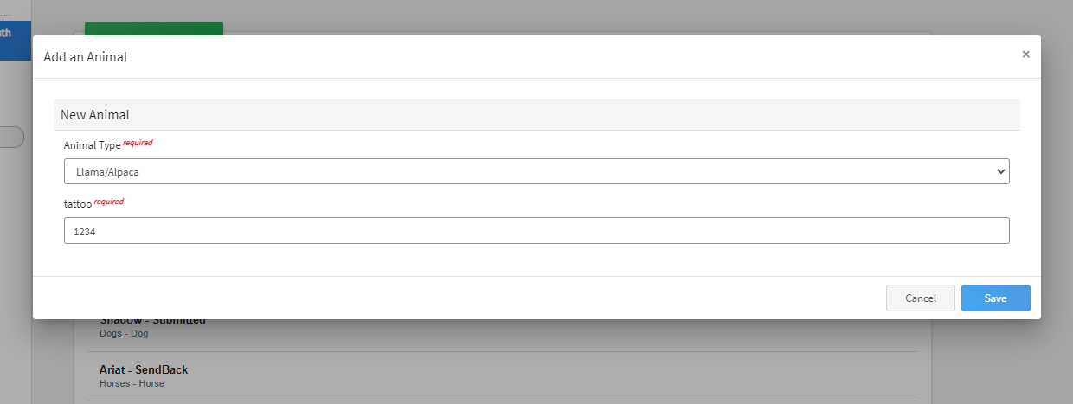

- Save
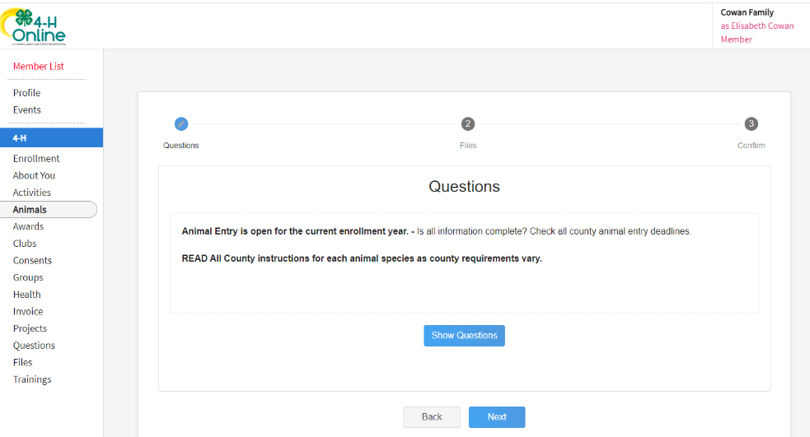
- Click “Show Questions”

- Fill out questions
  - Animal Name: Animal Name
  - Colors & Markings: colors and markings of animal
  - NAIA Premises ID: Not needed – leave blank
  - Owner or Leased: Mark if it is owned or leased
  - Purchased or Leased Date: When did you purchase or begin leasing the animal
  - FVRCP Vaccination Date: Date of last Vaccination
  - Animal Gender: Animal Gender
  - Tattoo: Same number you entered on the front page
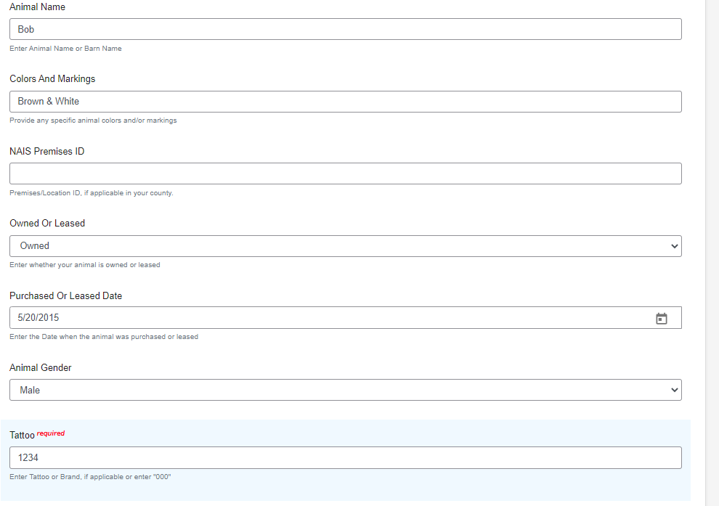

- Upload Files
  - Llama/Alpaca (Photo 1)- Front Picture
  - Llama/Alpaca (Photo 2) –Side Picture
  - County Use Form (Llama/Alpaca) - N/A Leave Blank
  - Llama/Alpaca (Lease Agreement)- Upload lease agreement here if animal is leased
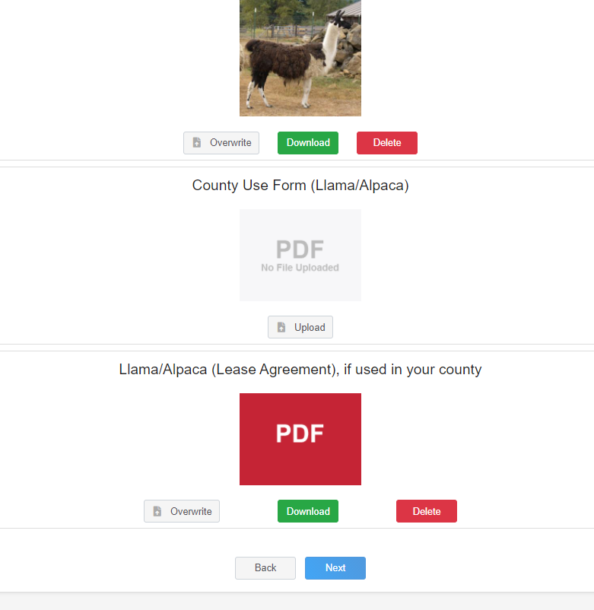

- Click next
- Review ID
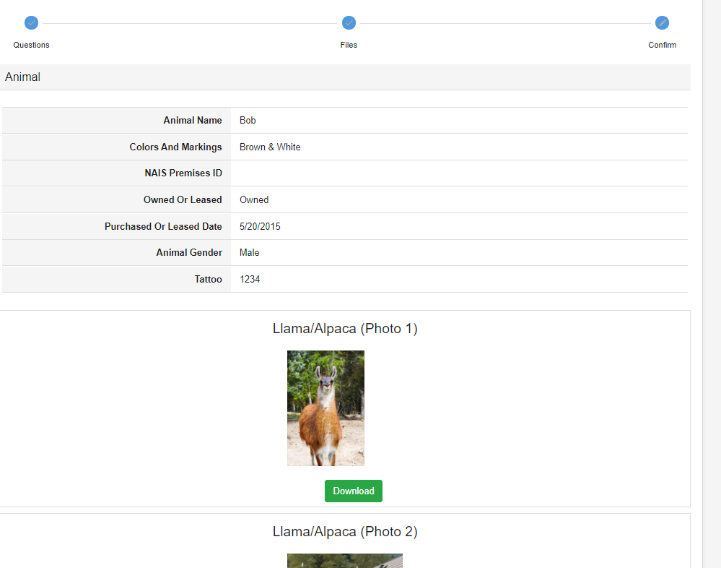

- Scroll Down & Hit Submit!

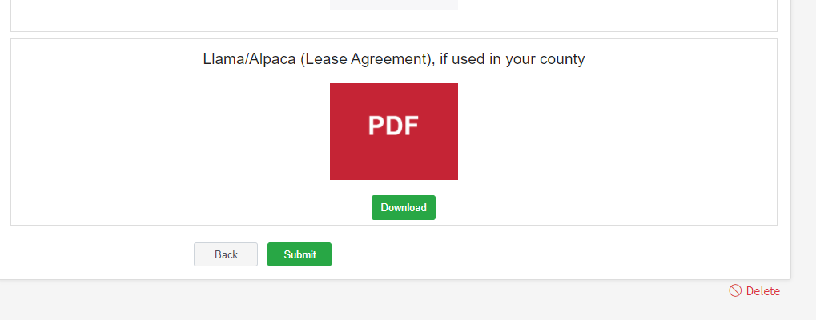

- See submitted ID
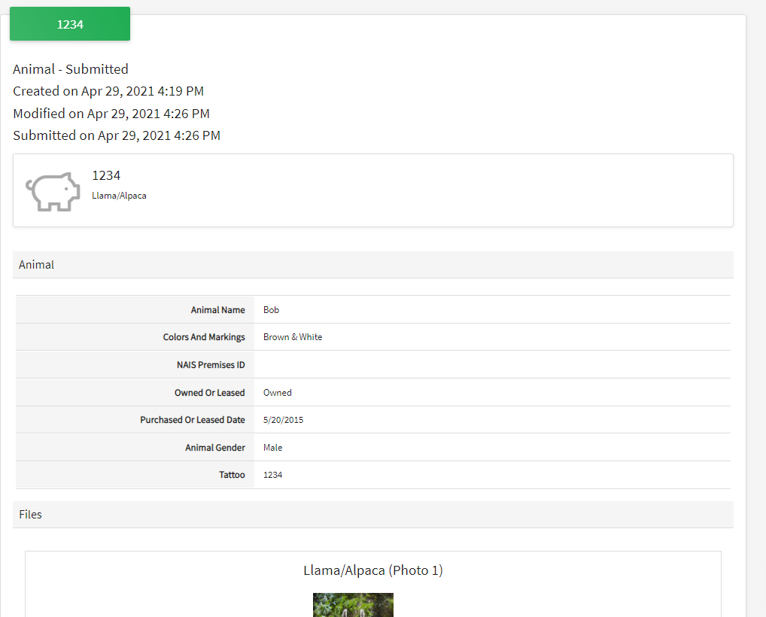

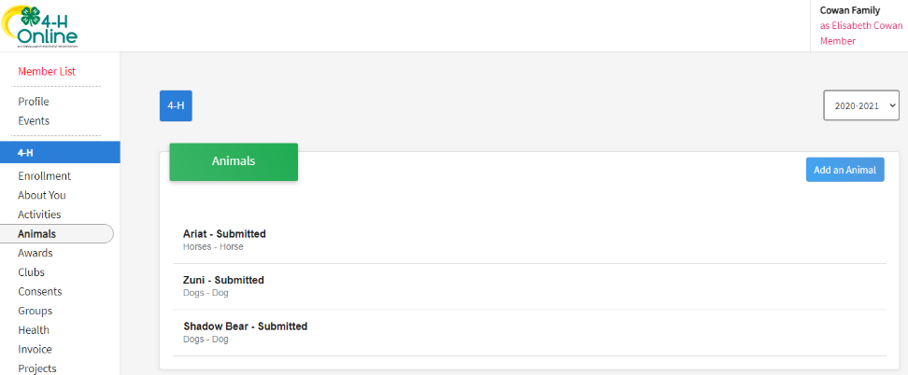
- Check! On the left side of your screen click on “Animals” again to bring you back to the Animal page for the youth. This will show you all animals ID’d for that youth! Here you see the 3 examples I have been working onL 2 dog’s (Zuni & Shadow Bear) and 1 horse (Ariat)

- Frequently Asked Questions
- 4Honline is not working for me- Keep trying and if it continues to not work please email Mercedes ASAP. The county ID deadline is June 1st and Mercedes needs a completed 4Honline ID or an email with necessary information by that deadline.

DO NOT WAIT UNTIL THE LAST MINUTE TO ID YOUR ANIMALS!

