4-H Non-Market Goat ID Guide
- Youth should log into their 4Honline account (https://v2.4honline.com/#/user/sign-in)
- On the left select Animals
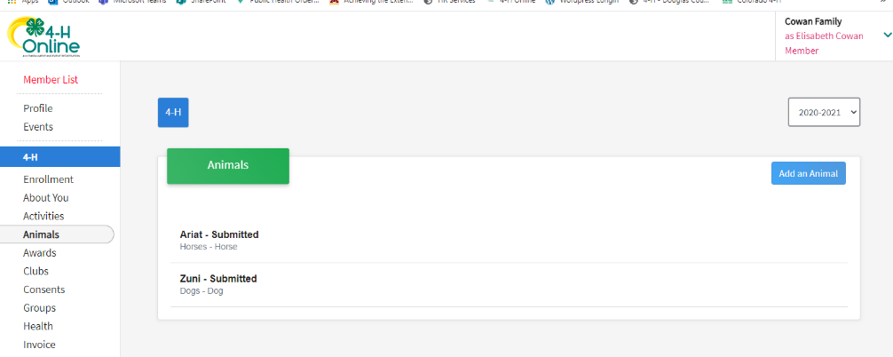
- Then Click “Add an Animal”

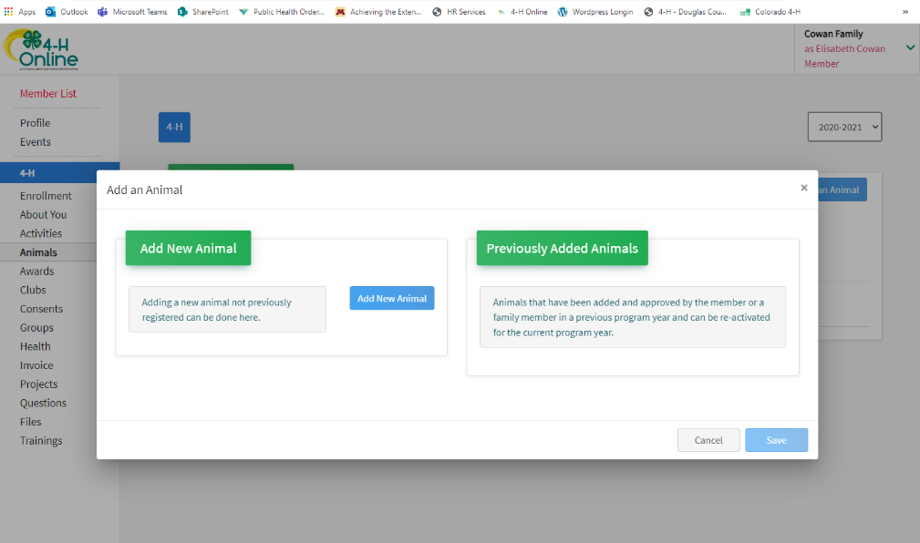
- Select “Add New Animal”

- Animal Type: Lots of different options for Non-Market Goats
  - Goat – Dairy Goat – Breeding
    - Tattoo – tattoo
  - Goat – Fiber
    - Tag – Tag Number
  - Goat – Meat Breeding
    - Tattoo – Tattoo
  - Goat – Utility
    - Tag – Tag Number
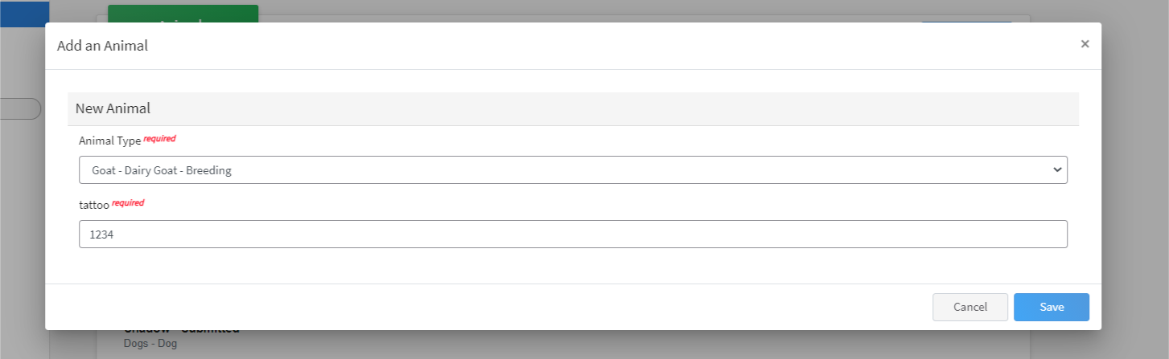
- Save

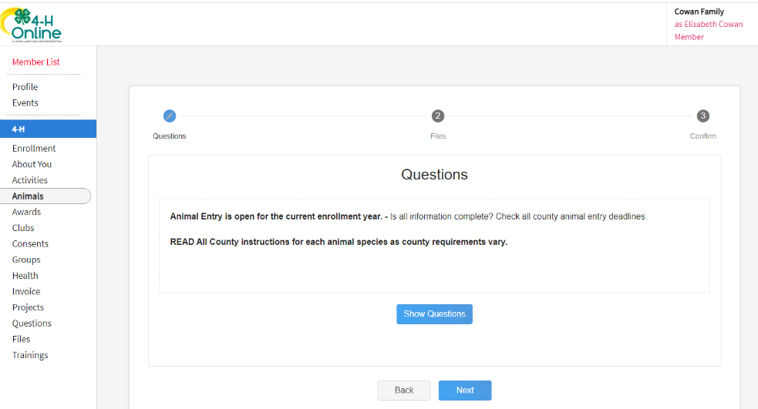
- Click “Show Questions”
- Fill out questions
  - Animal Name: Animal Name
  - Animal Birthday: Birthdate of animal OR Purchase Date
  - Birth Weight: Birth Weight OR weight at purchase date
  - Breed: Breed
  - Colors & Markings: Any distinguishing color or markings
  - NAIS Premises ID: Necessary for State Fair Nominations – Not required for Douglas County
  - Registration Number: Animals registration number
  - Scrapie Flock ID: Scrapie tag number if applicable
  - Animal gender: Animal gender
  - Tattoo: Animal’s Tattoo
  - Next
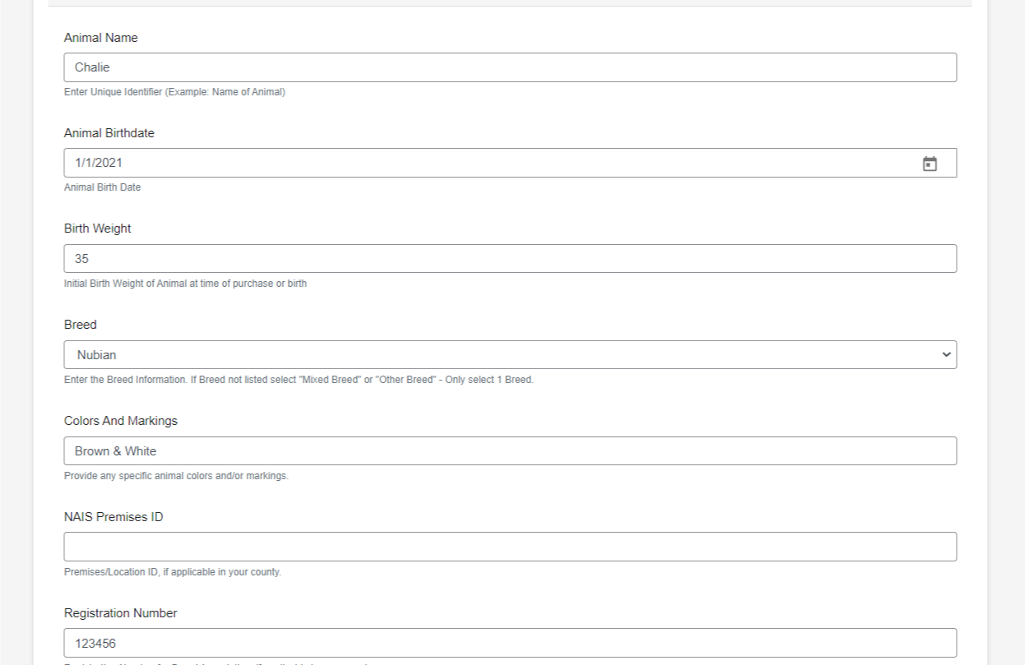

- Upload Files
  - Goat -Dairy Goat – Breeding (Photo 1)- Front Picture
  - Goat -Dairy Goat – Breeding (Photo 2)- Side Profile
  - Goat -Dairy Goat – Breeding (Photo 3)- Tattoo Picture
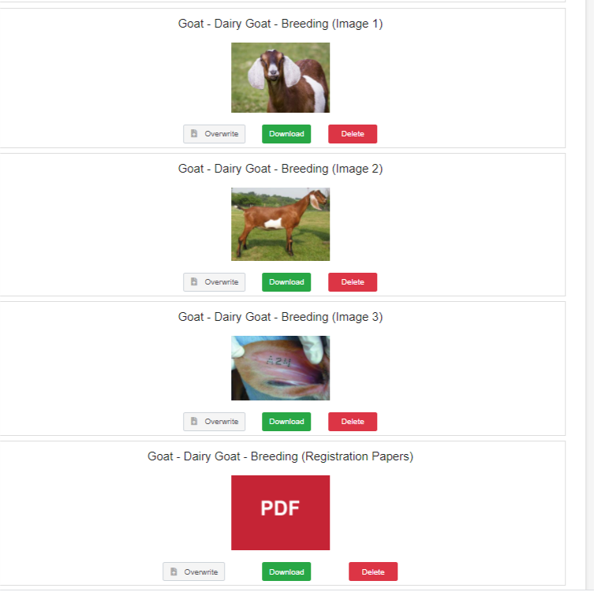
  - Goat - Dairy Goat - Breeding (Registration Papers) – Registration papers

- Click next

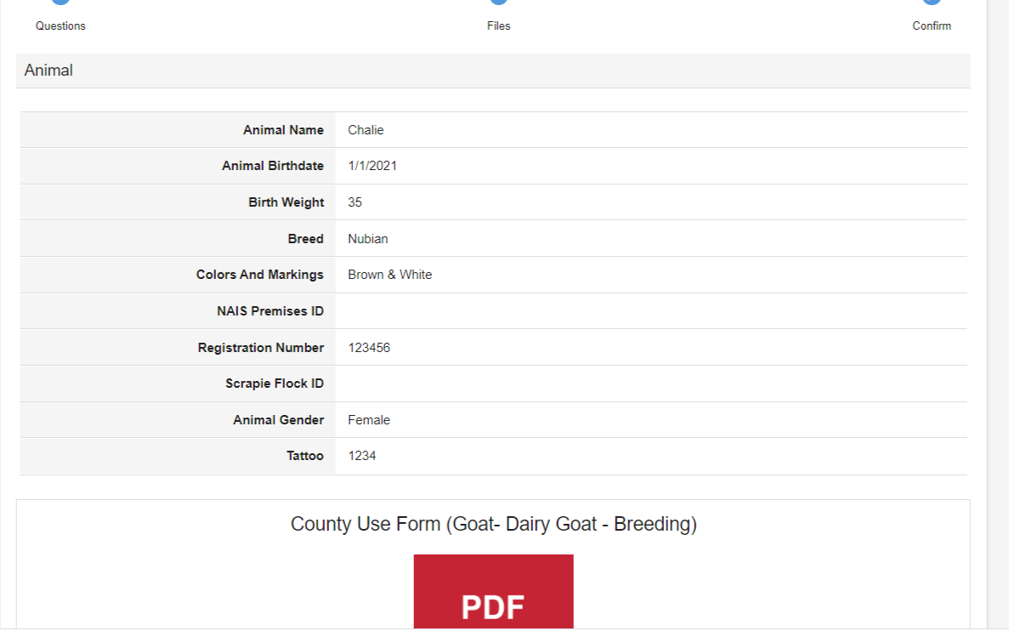
- Review ID

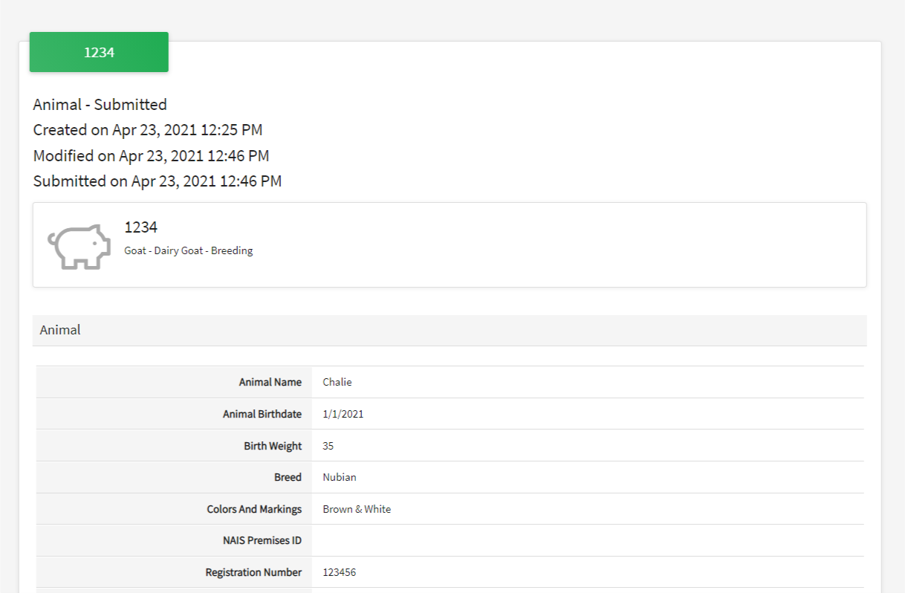
- Scroll Down & Hit Submit!

- See submitted IDCheck! On the left side of your screen click on “Animals” again to bring you back to the Animal page for the youth. This will show you all animals ID’d for that youth! Here you see the 3 examples I have been working onL 2 dog’s (Zuni & Shadow Bear) and 1 horse (Ariat)
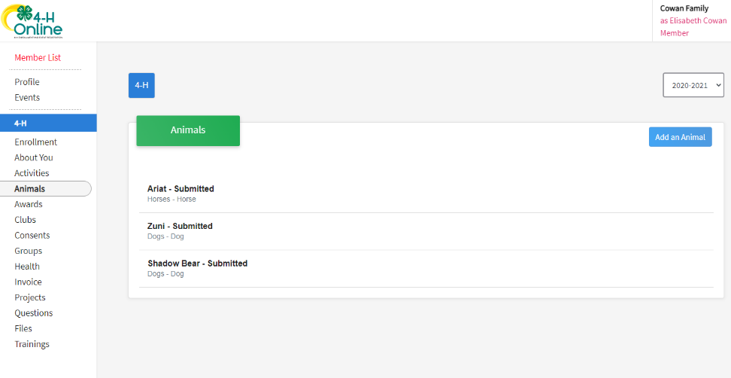

- Frequently Asked Questions
- 4Honline is not working for me- Keep trying and if it continues to not work please email Mercedes ASAP. The county ID deadline is May 1st and we need a completed 4Honline ID or an email with necessary information by that deadline.
- Different goat types have different questions – Fill them in to the best of your abilities prior to ID day on May 1st. We will do any “clean-up” we need after that.
- My goats do not have tattoos or registration papers yet- Fill them in to the best of your abilities prior to ID day on May 1st. We will tattoo the animal on ID day and help with any document “clean-up” after.

DO NOT WAIT UNTIL THE LAST MINUTE TO ID YOUR ANIMALS!

